FULL PITCH
Intro: “Hey, my name’s ______ with Aptive. I’m workin with the Johnsons, the Ryan’s and the Smith’s (I’m taking care of 5 of your neighbors this afternoon). It’s mainly the ants and the spiders (emphasize the bugs and pause)(or 2 common bugs in the neighborhood). If I can get you done as well, I’m doing it for below half.” (leave them hanging so they want to know the price).
(Eye contact, Touch and look at Aptive on shirts, Talk and point slowly, Don’t move hands too much, Slant your feet and body, and stay planted)
Pricing: Pest control is super simple, I come every 2 months, it’s $189 bucks, so super affordable. Where Pest Control gets more expensive is that initial service, it’s normally $389 because much more product, maintenance, labor, and sending a truck out just for you. While our trucks are here, we’re taking a full $100 OFF the initial service, doing it for just $289 bucks.
Service-You’ll notice that in each section of the service, you will need to explain three things– the problem, the feature and the benefit. Ensure that you are following this step by step process during each section of the service while also getting the customer to agree at the beginning of each point.
Eaves: “You’ve seen how the wasps and the spiders like to hang out in the eaves right? We need to take a 30 foot webster pole (demonstrate it) and put product on it in order to clean off all webs, and also take care of any wasps or spiders that crawl up there, all the way around the entire house. That way, nothing can breed, nest, hatch, and eventually drop inside the home.”
Base: “Now you have seen how little bugs will use these cracks to enter inside the home right? We need to power spray 3x3 feet all the way around the entire home to create a force field so that nothing can enter. Not only that, we have a product that can get them from outside of the walls during the winter.”
Yard: “Now, all the bugs come from the yard right? We are the only company in this industry that offers a full scale yard treatment. Most competitors only go 20-30 feet out, but we cover the front edge of the property, all the way to the back fence line of the property, and we can custom treat and inspect for over 40 pests at their breeding sites. This ensures nothing ever comes close to getting inside the home.”
Transitional Phrases
- What’s the square footage of your house?
- Where my guy is going to start is…
- I know you're going to love it…
- Best part about my service…
- Out here it’s not IF the bugs come, it's WHEN…
- I’m glad you brought that up…
- That’s exactly why the neighbors hired me…
- That’s why I love Aptive…
The Sales Path / Flow
“You have to drop your sales mentality and start working with your prospects as if they’ve already hired you.”
Ideally, the path to creating a customer who doesn’t already have a pest control service should look like:
Initial Approach → Prospect asks “What’s half” → Explain Price
→ Pitch Service → “Hard” Close → Overcome Objections (Re- solve, Ace, Close) / Fill Out Agreement
In this example, after your initial approach the prospect asks: “What’s half?” or “How much is it?”
Obviously, in these cases, you will explain the price first and then make sure they understand the features and benefits of the service.
Of course, not every interaction will perfectly follow this flow. The prospect might give a “hard” smokescreen up front, in which case your pitch might flow differently:
Initial Approach → Prospect gives one or more “hard” smoke- screens → Pitch Service → Explain Price → “Hard” Close → Overcome Objections (Resolve, Ace, Close) / Fill Out Agree- ment
In this situation, it is essential to share some value with the prospect before launching into the details of the price. Now that Aptive has become a premium service, we have many success- ful reps that choose to explain price LAST before the hard close. They want to be able to share the value of the service so the prospects’ buying temperature increases before they share the premium price.
Check with your leader on the best strategy given your team and area.
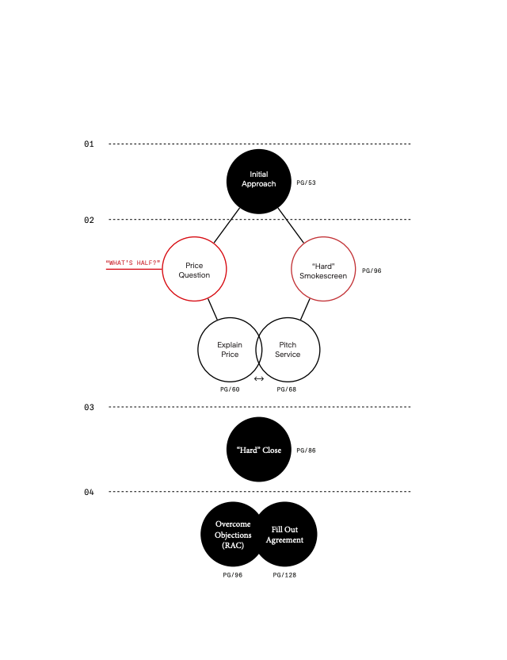
“Great salespeople are relationship builders who provide value and help their customers win.”
Standard Pitch Sales Script
SALES REP
“Hey, how’s it going?” “I’m (first name) with Aptive. It’s pest control. We’re taking care of [actual real neighbor], [actual real neighbor], and [actual real num- ber] others tomorrow. For them, it’s been the [pest issue #1] and the [pest issue #2]. If you can be here, I’m doing it for half off.”
CUSTOMER“What’s half?”“What’s the square footage of your home?”
About 3,500 sq. ft.
“Perfect. Normally, it’s three hundred and ninety-nine dollars for the initial service and then it’s just [price in your area] per visit after that. But, if you can be here, I’m taking two hundred dollars off, doing that first treatment for just one ninety nine. And that’s for EVERYTHING.”
“What [name of customer] loved is what we do here in the eaves. I’m sure you’ve seen the spider webs and wasp nests. We need to sweep these down ALL the way around the home and also treat. It looks nice not to have it up there, but it helps keep the spiders from getting in and dropping down into the home.”
“My main concern is here at the base of the home. Obviously, there are cracks and crevices here which are highways for the [pest issue #1] and [pest issue #2]. We need to treat three feet up and three feet out ALL the way around the base of the home. This will seal off the home and make sure bugs aren’t getting in.”
“Honestly, the best part of my service is what we do in the yard because that’s where the bugs like the [insert pest here] are nesting and breeding. We treat from the front curb ALL the way to the back fence. We’ll treat problem areas like grass, shrubs, mulch beds, taking care of the pests at the SOURCE”
“Now, would you like me to do the garage too? It’s included.”

